**IBM HackChallenge 2023**

|  |  |  |
| --- | --- | --- |
| **Team Name** | **:** | **Analytic Architects** |
| **Team Size** | **:** | **4** |
| **Bussiness Challenge** | **:** | **Malnutrition: A Disease That no one cares about** |

**Description:**

Create a comprehensive web application aimed at addressing malnutrition through diagnosis and analysis. The website will utilize IBM Cognos tools for data analysis and visualization. The main focus of the website is to help users to understand the reasons behind malnutrition, and receive personalized solutions. Additionally, the website will be capable of generating visual analytical representations on malnutrition across different countries.

**STEP BY STEP PROCEDURE:**

**1.DATA COLLECTION:**

For this project, data collection was a crucial initial step, involving the acquisition of datasets from the Kaggle website. The datasets were sourced from the link https://www.kaggle.com/datasets/ruchi798/malnutrition-across-the-globe. The provided datasets hold valuable information regarding malnutrition across different countries. Two specific datasets were gathered: "country-wise-average" and "malnutrition-estimates."

**Country-wise Average Dataset:**

The "country-wise-average" dataset contains aggregated information about various indicators and measures related to malnutrition across different countries. This dataset presents a comprehensive overview of malnutrition trends, including key statistics averaged at the country level. It encompasses aspects such as child stunting, wasting, underweight rates, and other relevant metrics.

Country-wise Average Dataset:

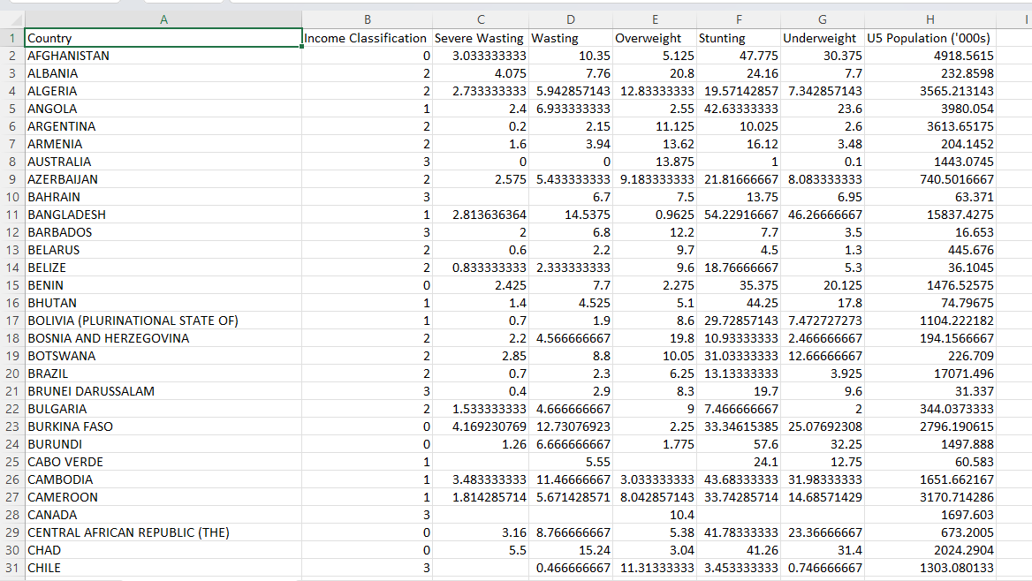

**Malnutrition Estimates Dataset:**

The "malnutrition-estimates" dataset comprises more detailed estimates and figures related to malnutrition. This dataset might encompass variables like socioeconomic factors, access to healthcare, dietary patterns, and environmental factors. Analyzing this dataset can provide a deeper understanding of the complex interplay between various factors and malnutrition rates.

Malnutrition Estimates Dataset:

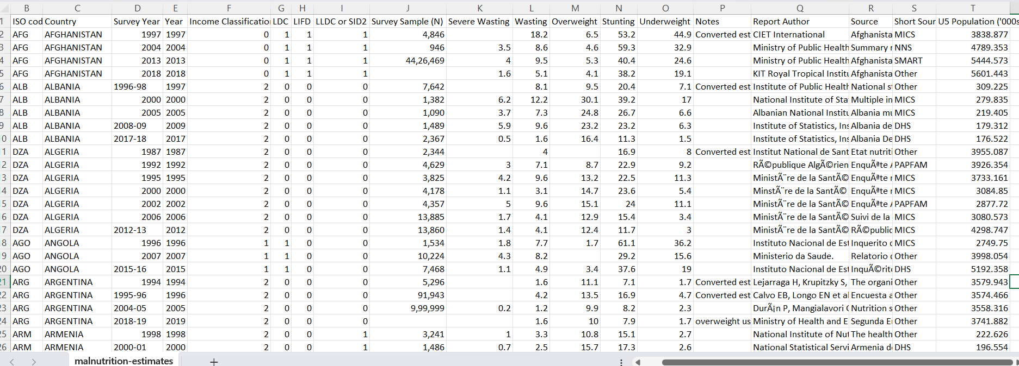

By collecting and utilizing these datasets, the project gains a robust foundation for conducting comprehensive analyses and deriving meaningful insights into the global malnutrition situation.

After completing the data collection phase and obtaining the relevant datasets, the next step in your project involved creating a data module in IBM Cognos. Let's delve deeper into what this entails:

**Creating a Data Module:**

1. **IBM Cognos:** IBM Cognos is a robust business intelligence and analytics platform that provides tools for data visualization, reporting, and analysis. It allows users to transform raw data into actionable insights through various components, one of which is the data module.
2. **Data Module:** A data module in IBM Cognos is a powerful tool that facilitates data integration, exploration, and modeling. It provides a user-friendly interface for users to interact with data sources, combine data from different sources, and create a unified view for analysis.

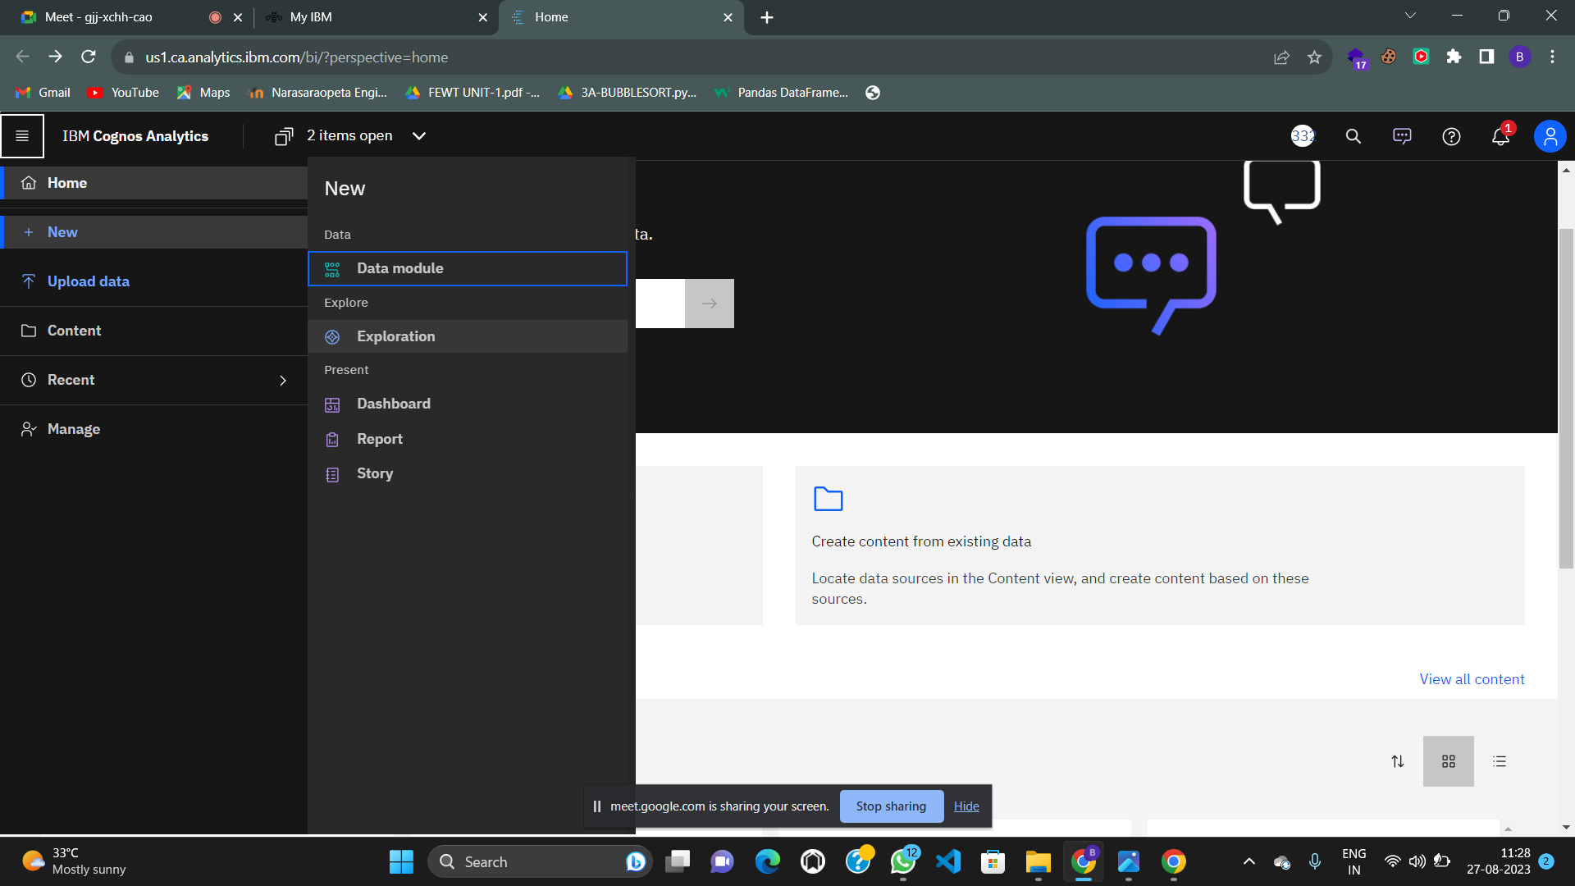

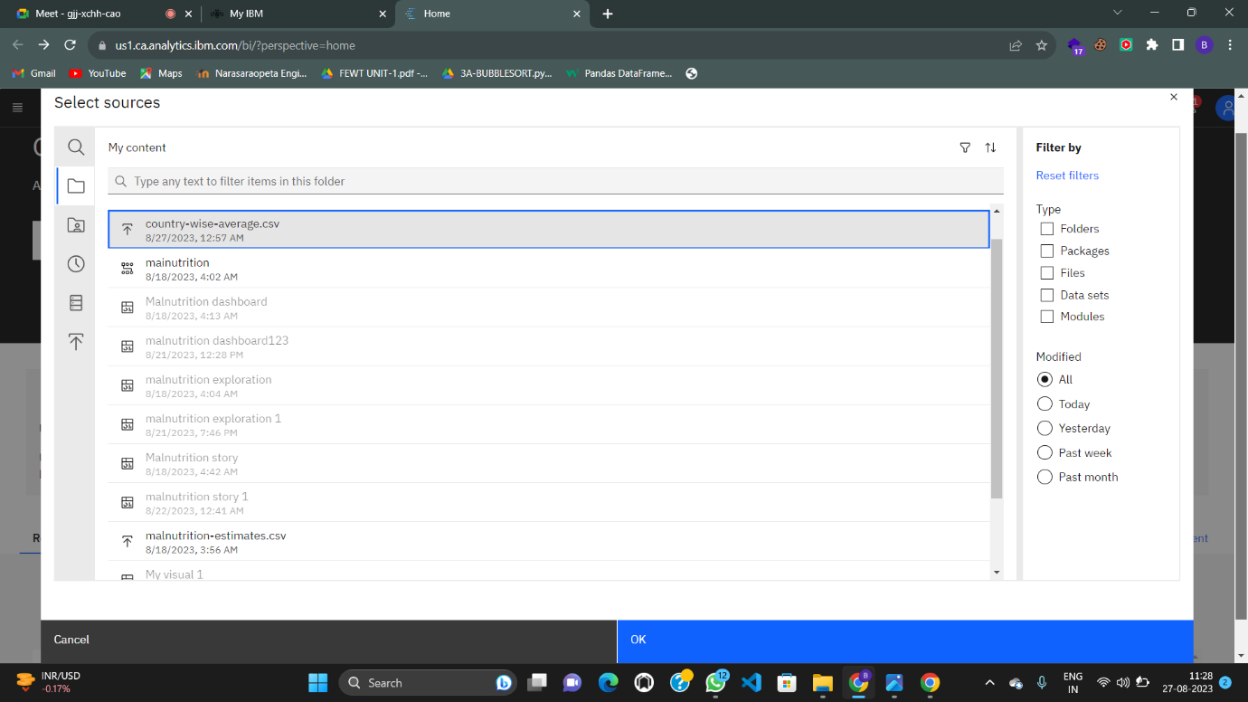

**2.DATA PREPARATION:**

In the data preparation phase of the project, our focus was on refining the collected datasets, "country-wise-average" and "malnutrition-estimates," through the application of essential data preprocessing techniques. One of the critical steps we took was addressing the issue of missing data or null values within the datasets.

**1.Handling Missing Data:**

Missing data can significantly impact the quality and reliability of any analysis. To ensure the integrity of our results, we employed a method to handle missing values within the datasets. Specifically, we adopted the approach of replacing the null values with the average value of the respective column.

**Null Value Replacement Strategy:**

For each column containing missing values, we calculated the average of the non-missing data within that column. This average value was then used to replace the missing values. This approach is known to provide a reasonable estimation while minimizing potential distortions introduced by incomplete data.

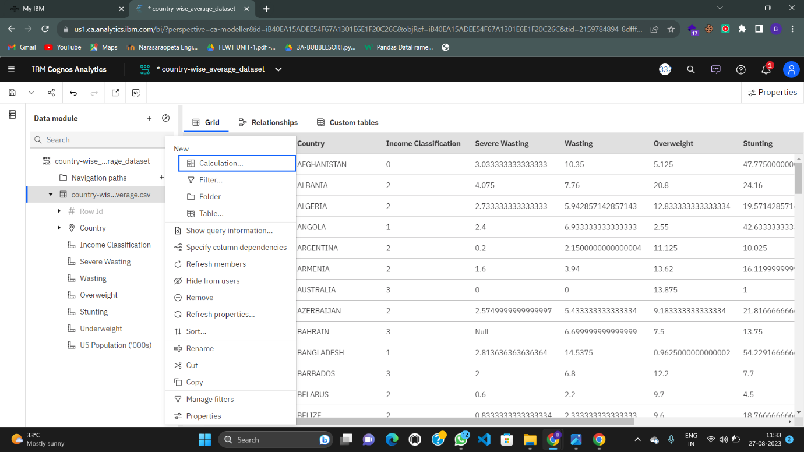

**Data Preparation in IBM Cognos: Replacing Null Values with Column Averages**

1. **Identifying Null Values:** During your data exploration phase within IBM Cognos, you likely identified columns within your datasets that contained missing or null values. These missing values could potentially disrupt the accuracy and reliability of any subsequent analysis.
2. **Null Value Replacement Strategy:** To address the issue of null values, you implemented a method to replace these missing entries with the average value of their respective columns. This approach involves calculating the average of the non-null values within a column and then using that average to fill in the missing entries.

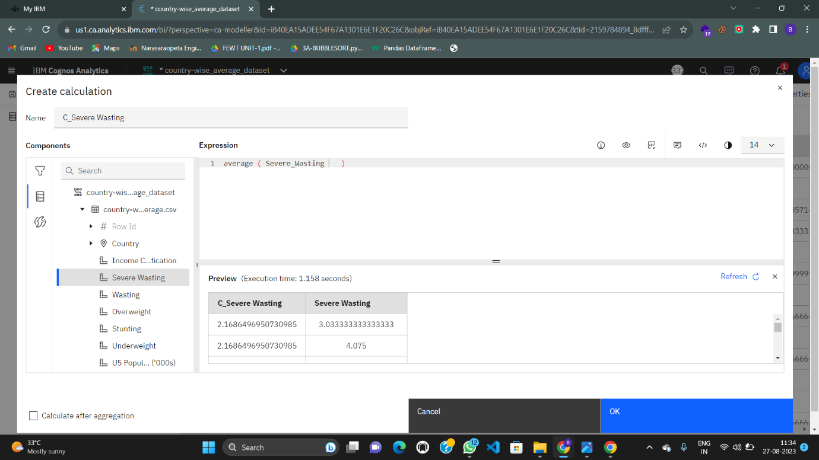

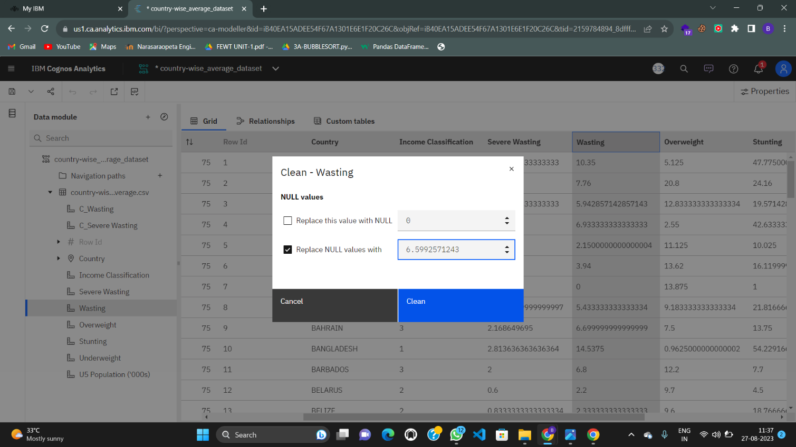

**3.Data Visualization:**

Data Visualization: Creating Dashboards, Stories, and Reports

In the data visualization phase of your project, you leveraged the capabilities of IBM Cognos to create compelling and informative visualizations that convey insights from your malnutrition datasets. Here's an overview of the components you developed:

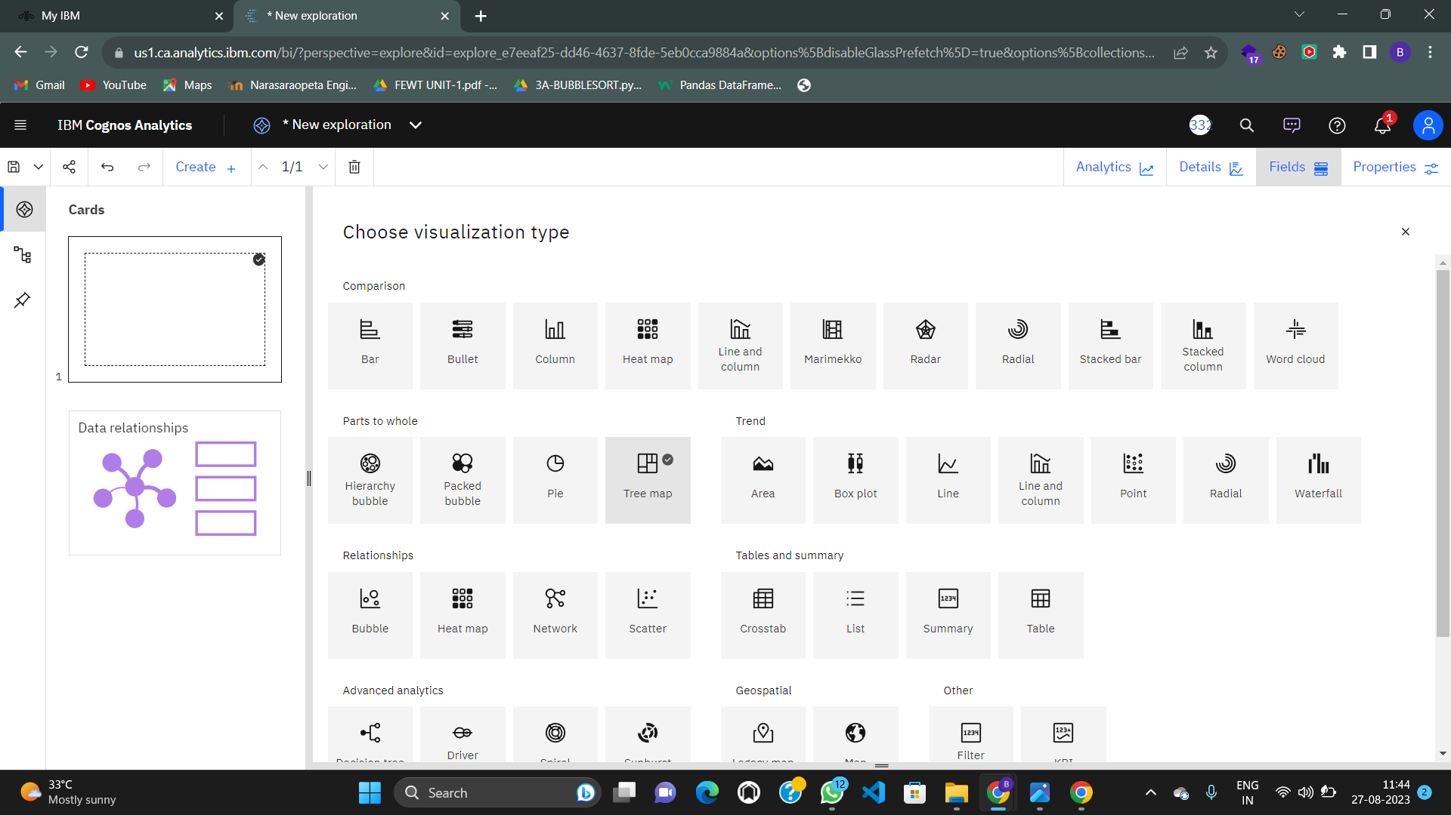

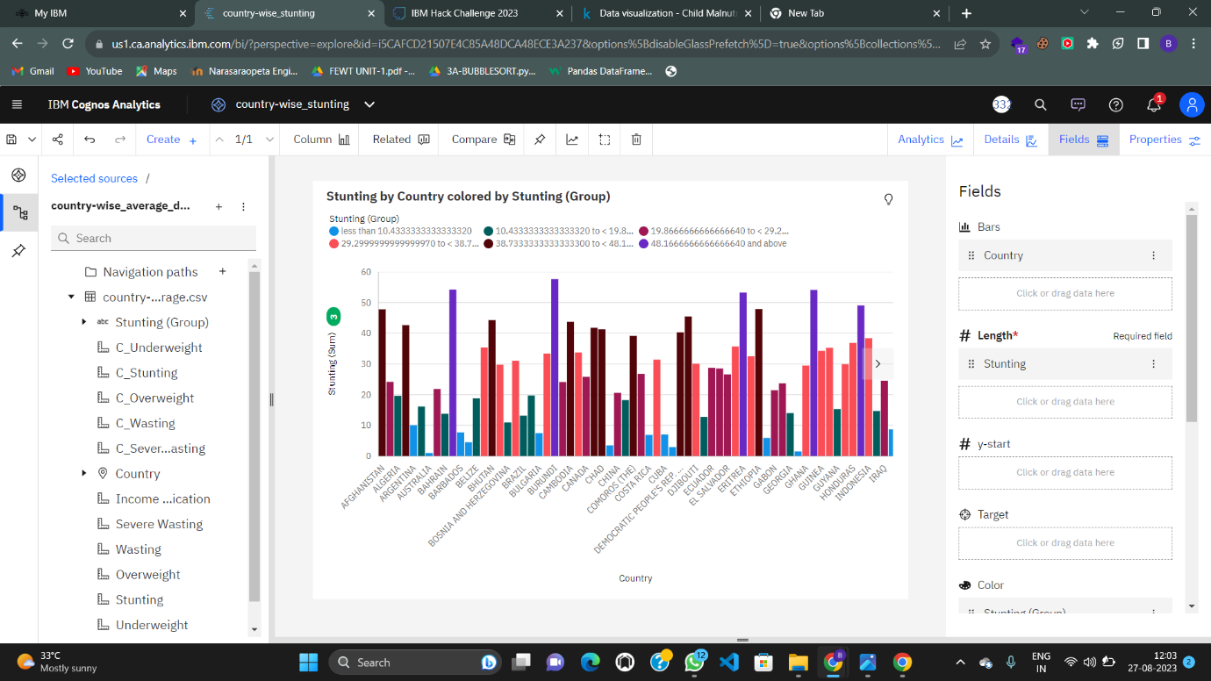

1. **Dashboards:** Dashboards are interactive visual displays that consolidate information from different sources into a single, accessible interface. In IBM Cognos, you likely designed dashboards that provide a real-time snapshot of key metrics and trends related to malnutrition across countries.
   * **Visual Elements:** You incorporated various visualization elements such as charts, graphs, tables, and maps to showcase different dimensions of malnutrition data. These visual elements make it easy for users to grasp complex information at a glance.
   * **Interactivity:** Interactive features like filters, slicers, and drill-down options enable users to customize their view of the data, focusing on specific countries, time periods, or metrics of interest.

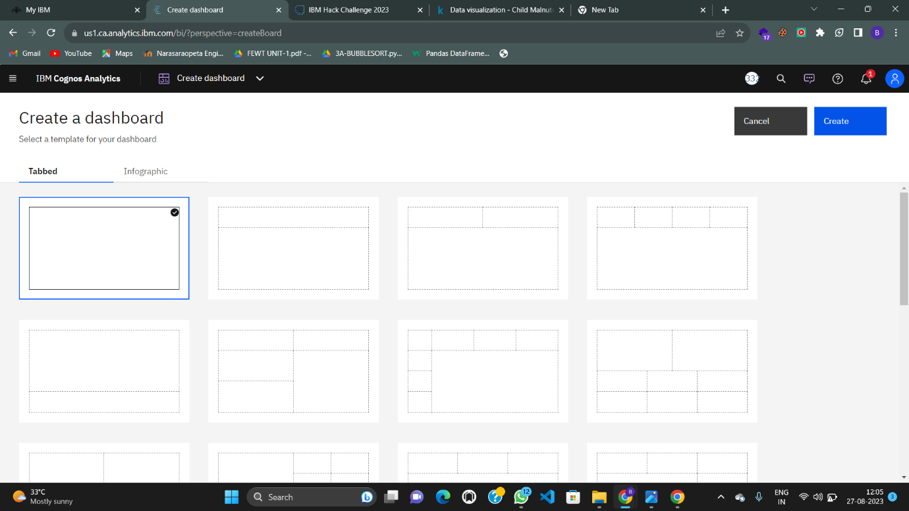

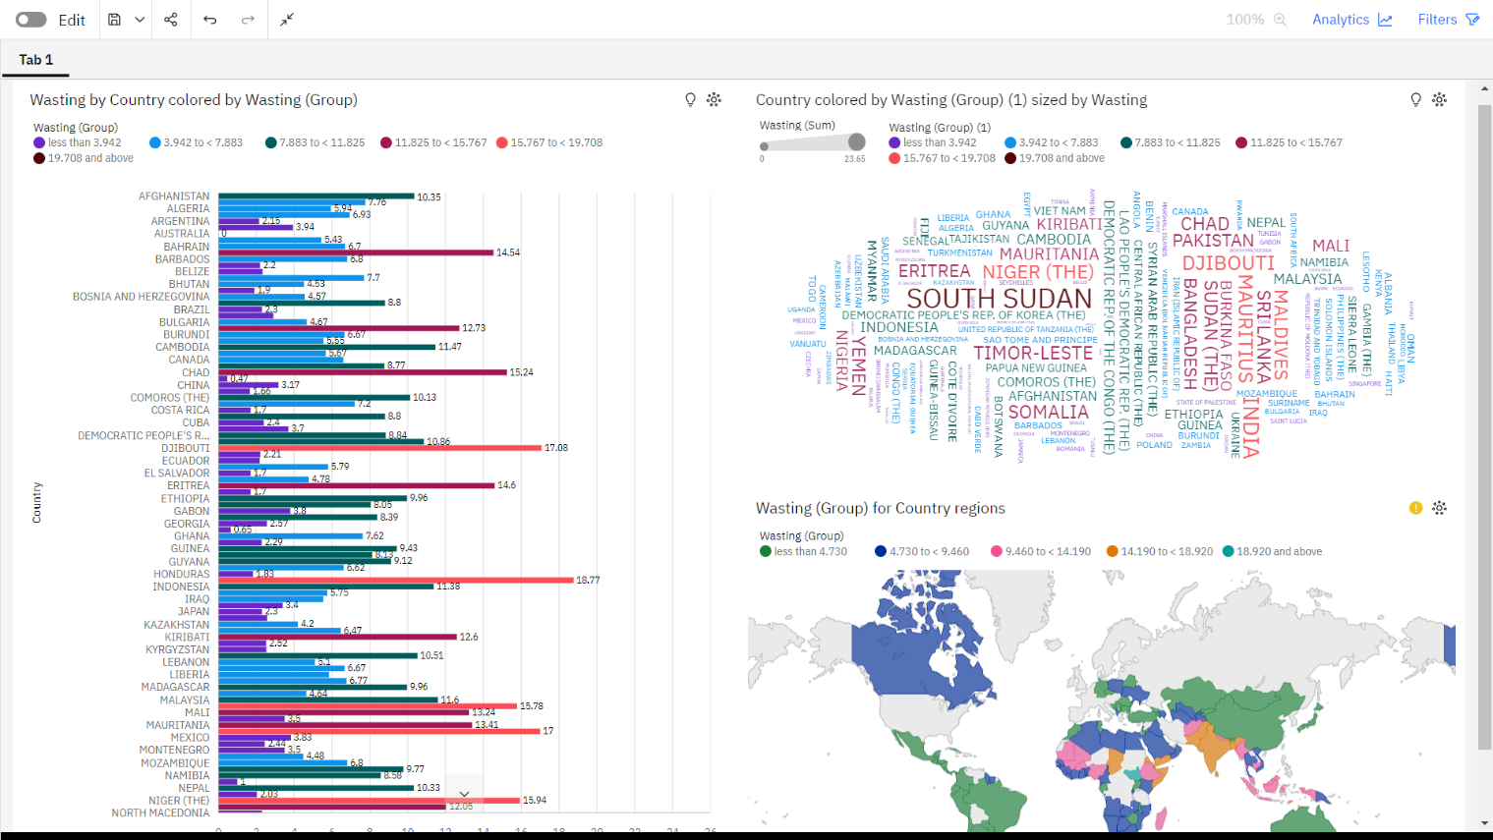

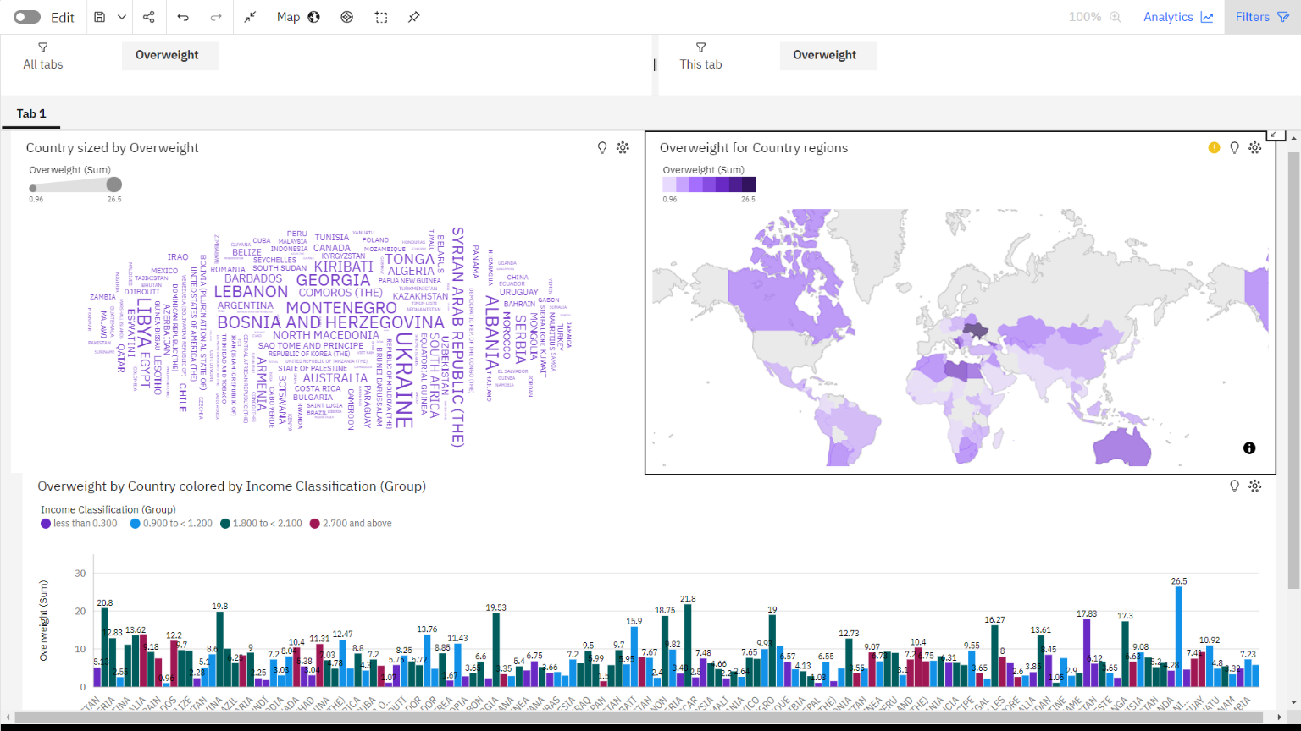

1. **Stories:** A story is a dynamic sequence of visualizations and narratives that guide users through a particular analysis or set of insights. Within IBM Cognos, you created stories that provide a structured narrative around malnutrition trends and their underlying factors.
   * **Narrative Flow:** Your story likely starts with an introduction to the malnutrition issue, followed by a series of visualizations that gradually reveal insights. Each visualization contributes to the overall story arc, leading to key takeaways and conclusions.
   * **Annotations:** Annotations and annotations, which you added to specific visualizations, help highlight noteworthy points, trends, or anomalies within the data.

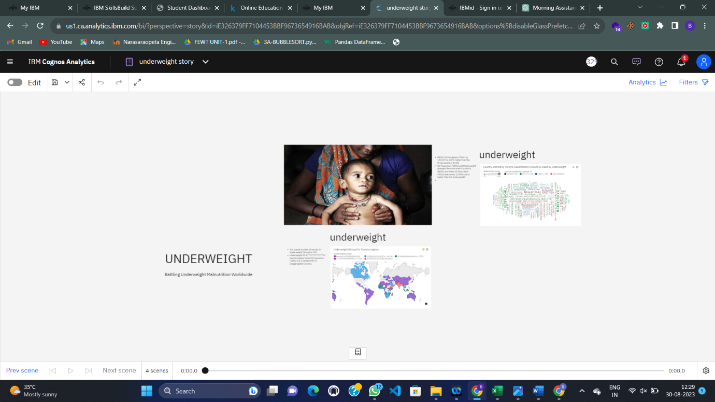

1. **Reports:** Reports are formal documents that present data and analysis findings in a structured format. In IBM Cognos, you generated reports that offer in-depth insights into the malnutrition datasets.
   * **Structured Presentation:** Your reports likely follow a structured format, including an executive summary, methodology, findings, and conclusions. Visualizations are integrated within the report to support the analysis presented in the text.
   * **Data Context:** Reports provide a broader context for understanding the data and its implications. You might have included background information, research objectives, and explanations of the methodologies employed.

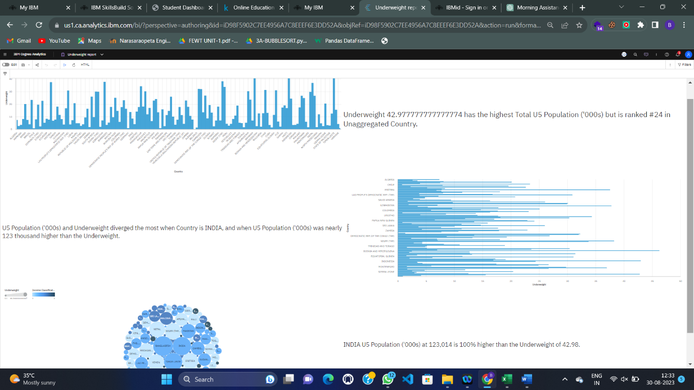

**ALL MY VISUALISATIONS:**

